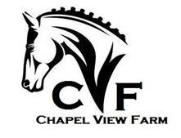
CHAPEL VIEW, LLC
14290 Chapel Lane
Leesburg, VA 20176
(703) 994-0430
RELEASE AND HOLD HARMLESS AGREEMENT
The Undersigned assumes the risks inherent in all horse-related activities, including but not limited to bodily injury and physical harm or death to the horse, rider, and/or spectator.
Therefore, the Undersigned does hereby agree to indemnify and hold harmless Jacquelyn D. Ross, Chapel View, LLC. and its members and employees, and further release them from any liability or responsibility for accident, damage, injury, death, or illness to the Undersigned or to any horse owned by the Undersigned or to any family member or spectator accompanying the Undersigned.
Signature __________________________________________ Date ________________
Print Name, Address and Telephone Number:
_______________________________________________
____________________________________________
____________________________________________
____________________________________________
Email : _______________________________________________________
Signature, Parent or Guardian
___________________________________ Date _______________
Emergency Contact
Name ___________________________ Phone ________________________

